**DESAIN UI UX DASHBOARD**

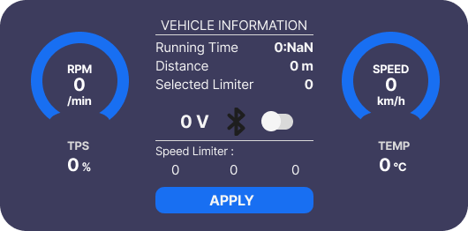

#include <iostream>

#include <string>

using namespace std;

class Vehicle {

private:

int rpm;

float speed;

int tps; // Throttle Position Sensor in percentage

float temperature;

float voltage;

bool bluetooth;

int speedLimiter[3];

string runningTime;

float distance;

public:

Vehicle() {

rpm = 0;

speed = 0;

tps = 0;

temperature = 0;

voltage = 0;

bluetooth = false;

speedLimiter[0] = speedLimiter[1] = speedLimiter[2] = 0;

runningTime = "0:NaN";

distance = 0;

}

void displayInfo() {

cout << "\n=== VEHICLE INFORMATION ===\n";

cout << "Running Time: " << runningTime << endl;

cout << "Distance: " << distance << " m" << endl;

cout << "Selected Limiter: " << speedLimiter[0] << ", " << speedLimiter[1] << ", " << speedLimiter[2] << endl;

cout << "RPM: " << rpm << " /min" << endl;

cout << "Speed: " << speed << " km/h" << endl;

cout << "TPS: " << tps << "%" << endl;

cout << "Temperature: " << temperature << "°C" << endl;

cout << "Voltage: " << voltage << " V" << endl;

cout << "Bluetooth: " << (bluetooth ? "ON" : "OFF") << endl;

}

void setRPM(int newRpm) {

rpm = newRpm;

}

void setSpeed(float newSpeed) {

speed = newSpeed;

}

void setTPS(int newTps) {

tps = newTps;

}

void setTemperature(float newTemp) {

temperature = newTemp;

}

void setVoltage(float newVoltage) {

voltage = newVoltage;

}

void toggleBluetooth() {

bluetooth = !bluetooth;

}

void setSpeedLimiter(int limiter1, int limiter2, int limiter3) {

speedLimiter[0] = limiter1;

speedLimiter[1] = limiter2;

speedLimiter[2] = limiter3;

}

void applySettings() {

displayInfo();

cout << "\nSettings applied successfully!\n";

}

};

int main() {

Vehicle car;

int rpmInput, tpsInput, limiter1, limiter2, limiter3;

float speedInput, tempInput, voltageInput;

char bluetoothToggle;

cout << "Welcome to Vehicle Information System!\n";

// Input data from user

cout << "\nEnter RPM (/min): ";

cin >> rpmInput;

car.setRPM(rpmInput);

cout << "Enter Speed (km/h): ";

cin >> speedInput;

car.setSpeed(speedInput);

cout << "Enter TPS (%): ";

cin >> tpsInput;

car.setTPS(tpsInput);

cout << "Enter Temperature (°C): ";

cin >> tempInput;

car.setTemperature(tempInput);

cout << "Enter Voltage (V): ";

cin >> voltageInput;

car.setVoltage(voltageInput);

cout << "Do you want to toggle Bluetooth? (y/n): ";

cin >> bluetoothToggle;

if (bluetoothToggle == 'y' || bluetoothToggle == 'Y') {

car.toggleBluetooth();

}

cout << "Set Speed Limiter (3 values):\n";

cout << "Limiter 1: ";

cin >> limiter1;

cout << "Limiter 2: ";

cin >> limiter2;

cout << "Limiter 3: ";

cin >> limiter3;

car.setSpeedLimiter(limiter1, limiter2, limiter3);

// Apply settings

cout << "\nApplying settings...\n";

car.applySettings();

return 0;

}